**7. Kubernetes NodePort Service and Pods Demo**

--- **note** – in this lesion, we are going to create pod and expose the pod to internet using nodeport service

**Demo - Expose Pod with a Service**

--- **note** - Expose pod with a service (NodePort Service) to access the application externally (from internet)

**#Ports**

**port:** Port on which node port service listens in Kubernetes cluster internally

**targetPort:** We define container port here on which our application is running.

**NodePort:** Worker Node port on which we can access our application.

**# Create a Pod**

--- **kubectl run <desired-pod-name> --image <Container-Image> --generator=run-pod/v1**

--- **kubectl run my-first-pod --image stacksimplify/kubenginx:1.0.0 --generator=run-pod/v1**

**# Expose Pod as a Service**

--- **kubectl expose pod <Pod-Name> --type=NodePort --port=80 --name=<Service-Name>**

--- **kubectl expose pod my-first-pod --type=NodePort --port=80 --name=my-first-service**

**# Get Service Info**

--- **kubectl get service**

--- **kubectl get svc**

**# Get Public IP of Worker Nodes**

--- **kubectl get nodes -o wide**

--- **Important Note about: target-port** - If target-port is not defined, by default and for convenience, the targetPort is set to the same value as the port field.

**#Below command will fail when accessing the application, as service port (81) and container port (80) are different**

--- **kubectl expose pod my-first-pod --type=NodePort --port=81 --name=my-first-service2**

--- **kubectl exp#Expose Pod as a Service with Container Port (--taret-port)**

**ose pod my-first-pod --type=NodePort --port=81 --target-port=80 --name=my-first-service3**

**# Get Service Info**

--- **kubectl get service**

--- **kubectl get svc**

**# Get Public IP of Worker Nodes**

--- **kubectl get nodes -o wide**

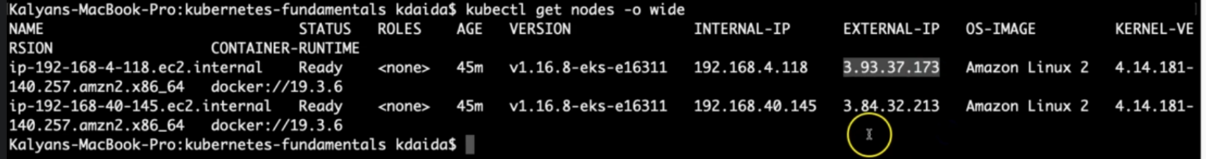

--- **note** – under **EXTERNAL-IP**, you will find some ip’s here those ip’s are belongs to worker nodes or instances. You can use that IPS to access the application over the internet.

--- **note** – service is across the worker nodes.

**Access the Application using Public IP**

--- **http://<node1-public-ip>:<Node-Port>**